UEAW LIGHT SIDE CAMPAIGN
ERA 1: MANDALORIAN WARS/JEDI CIVIL WAR

Intro: Republic has been at war with the Mandalorians for a while. Finish the job.
Map:
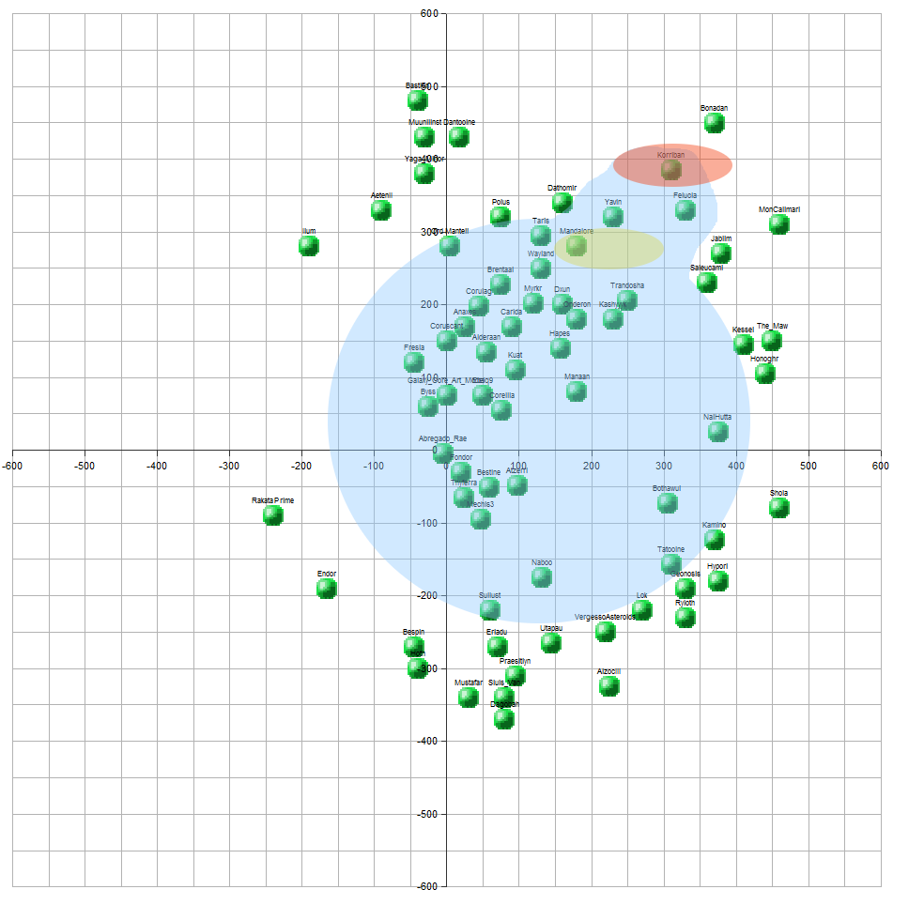
Blue: Republic space
Yellow: Mandalorian [Pirate] space
Red: Sith space

Player starts with forces concentrated on the Mandalorian border; very little elsewhere.

The player will learn of the Mandalorian defeat at the hands of Revan and Malak, and their disappearance to search for the rest of the Mandalorians

Sandbox break

Player is told that Revan and Malak have returned with a massive fleet.

Objective 4: defend against Sith invasion

Massive attacks everywhere; player is fought back

Objective 5: capture Revan

Player goes to the planet where Revan is located; beats him in space. Revan is presumed dead.

Sandbox break. Random Sith attacks.

Player learns of Revan's survival and search for the Star Forge. Ebon Hawk appears.

Objective 6: find the Star Forge by conquering the planets the star maps are on, with the Ebon Hawk in the fleets.

Player has to take Tatooine, Kashyyyk, Manaan and Korriban. Rakata Prime is revealed.

Objective 7: build up a fleet including the Ebon Hawk and take out the Star Forge.

Player destroys Star Forge. Revan leaves. Ebon Hawk disappears.
Detail:
- Player must escort Ebon Hawk to a location on the rim of the Star Forge
- Player must defend against waves of Sith attacks until Darth Malak is defeated
- Once he is defeated, the player can attack and destroy the Star Forge.

Sandbox break; player can attack remaining Sith worlds, which are now dead.

Player is told that the Jedi are being killed by an unknown force. Jedi Exile is announced. A number of planets secede to the Sith due to the Jedi dying on them.

Objective 8: Help the Exile.

Ebon Hawk reappears. Player must take it to Dantooine, Nal Hutta and Onderon, eliminating the Sith there.

Objective 9: Defeat Darth Nihilus

Another battle requiring the Ebon Hawk; massive Sith fleet, Darth Nihilus in the Ravager.

Objective 10: Extend the Republic (sandbox)
More planets appear, owned by pirates/Mandalorians. Random attacks by pirates during this period.

Player learns that another Jedi has turned to the dark side, forming another Sith Empire.

Objective 11: Light and Darkness War

Sith strike against many worlds. Player has to fight them off. Again.

Player informed of the Ruusan reforms.

Sandbox

Galaxy expands a little more

Pirate raids from time to time i.e. the next 1000 years or so

END ERA 1

ERA 2: THE CLONE WARS

Naboo is invaded by the Trade Federation (e.g. CIS)

Objective 1: break the Naboo blockade

Yeah so it's not canon. But it's fun. Player gets low-level Clone Wars units to send against the Lucrehulk blockade. Droid control ship is the main target.

Sandbox break. Outer rims joins the CIS.

Player is informed that a clone army is being readied on Kamino for their use.

Objective 2: Invade Geonosis

Fleet must contain Acclamator-I Class Assault Ships, including the Arrestor.

Objective 3: Defend the Republic (sandbox)

CIS attack a number of positions in the Outer Rim.

Objective 4: Battle of Coruscant

Defend Coruscant from the CIS assault. Basically a scripted battle as far as units go, if possible.

Objective 5: Outer Rim Sieges

Take back the Outer Rim planets for the Republic

Short sandbox break

ORDER 66

END ERA 2
ERA 3: THE GALACTIC CIVIL WAR

Cut scene. Entire galaxy revealed bar a couple of planets.

Player now in control of the Rebellion. Planets set to reflect galactic control at the onset of the GCW era.

Episode IV: A New Hope

Basically run the Rebel campaign from vanilla EaW, except more planets are visible and tech is basically all available. That covers A New Hope. Of course, a lot of the missions (the land ones!) will be cut. Rebels pull back to far systems.

Episode V: The Empire Strikes Back

Rebels now only have Hoth and a few outer rim systems. Battle of Hoth cinematic? Would be hell trying to get transports past ISDs. Various battles all over the galaxy.

Episode VI: Return of the Jedi

DSII existence discovered. Player must destroy it, Millennium Falcon and Rogue Squadron required.

Sandbox: take galaxy from Empire

(Imperial forces should be less effective)

END ERA 3

ERA 4: THE NEW REPUBLIC

Thrawn and the Imperial fleet arrives, and should take out most of the player's outer rim territories. Specifically:

Wayland, Sluis Van, Ord Mantell, Coruscant

Player must fight back, and face down Thrawn. Once Thrawn is dead, game over, victory to the Light Side. Ignoring all the other wars afterwards, of course.

THIS DOCUMENT IS A WORK IN PROGRESS

